Professional School Of Food Technology’s Story of Impact
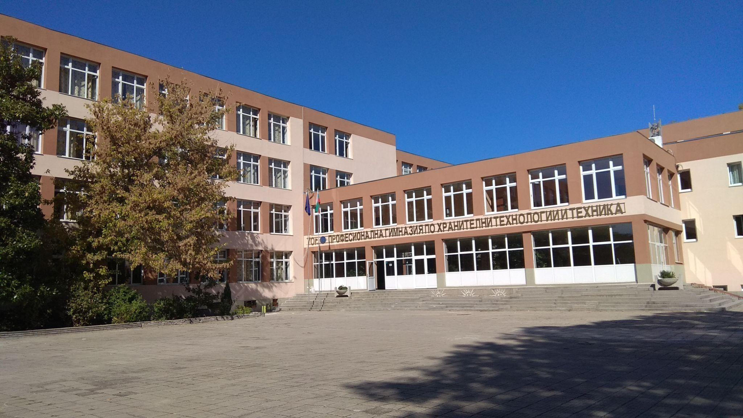
Located in Bulgaria, Professional School Of Food Technology (PSFT) has a student count of 780 with 60 teachers and 19 people in the administrative and support staff.
We have been using Google for Education tools for 4 years, making use of Google Workspace for Education Fundamentals and 196 Chromebooks (160 in our domain, 36 from the Ministry of Education and Science in their domain)

Give an overview of how you are using Google for Education tools in your organisation.
At the end of 2017, the G Suite for Education (now Google Workspace For Education) service was activated and set up in the Professional School of Food Technology, Plovdiv.

Google tools are an essential partner in the updating of teaching methods and engage our students in the active implementation of new technologies. In our school they are mostly used for:
- GMail and Groups– we use it for communication between the PSFT’s leadership, the teachers and the students;
- My Drive – every teacher, employee and student uses the unlimited storage in their account not only for school work, but also for personal files.
- Shared Drives – in PSFT we have several shared drives: a main one, filled with administrative information, photos and videos for the school, an e-library with teaching materials for professional subjects (also in Google Sites version); a shared drive only for the school leadership with important administrative documents; shared drives with materials, managed by different groups of teachers.
- Docs – we use the online text editor for creating and formatting all kinds of text documents - school warrants, plans, programs, messages, reports, MMTS for various subjects, etc.
- Sheets – online spreadsheets are used by class teachers to perform various calculations related to statistics for their classes, as well as from the school’s leadership to form and analyze all kinds of school data.
- Slides - this app facilitates the perception of information by both teachers/staff and our students; students also create presentations about projects they work on, as well as for other school tasks.
- Forms – constantly used to collect information and data in the form of surveys, as well as to conduct test tasks with students.
- Calendar – the accessible and easy planning of the activities through the calendar gives the opportunity to organize various events in an online environment - pedagogical councils, trainings, students consultations, etc.
- Drawings – used by teachers and students in different subjects (Information Technology, Technical Drawing and other professional subjects) to create various schemes and images.
- Meet And Chat – Google Meet and Chat allow real-time communication between all participants in the educational process and is used constantly for synchronous learning in an electronic environment through the various Google classrooms and class calendars.
- Sites – used by students in IT classes, extracurricular activities and projects for various subjects; the PSFT’s e-library will also be transformed with Sites.
- Jamboard – many of our teachers use it in their classes, because it replaces any interactive whiteboard and allows sketching, writing text, and working with a document in an interactive way.
- Google Maps – often used in History And Civilization classes, as well as in Geography and Economics.
- Google Expeditions – we use it to carry out comprehensive 360-degree virtual expeditions in History, Geography, English, and augmented reality is used to view 3D models in Science classes.
- Google Earth - a teacher plans an educational route or assigns the students to compile one; then all students take part in the walk along this route. It is used by English teachers, as well as by History and Geography teachers, often with transdisciplinary lessons.
- Google Classroom - each school year we have between 450 and 550 active virtual classrooms; with the help of Google Classroom, teachers organize the learning process in a convenient electronic form, create a course, PSFT leadership joins existing courses and monitor the learning process, teachers organize, upload materials, create and check students' assignments and tests, set questions, communicate. At the end of each school year, teachers archive some of their classrooms, while other classrooms become templates and are used during the next school year by the same or/and other teachers. If a teacher teaches the same subject next school year, in the same class, the classroom of the particular class and subject is kept, thus giving students direct access to the teaching materials of the previous school years.

What benefits and impact has your organisation seen from using Google for Education tools?
1. Students have increased their digital competencies through the use of the Google Workspace for Education tools.
2. Teamwork has been facilitated, communication has become more convenient, and the exchange of information has become much more secure. The availability of shared resources provided an opportunity for better and faster work.
3. Google Workspace For Education simplifies the management of administrative processes, and at the same time reduces the cost of consumables. An opportunity for fast and secure exchange of information and documents has been provided.
4. We created an e-library with teaching materials for professional subjects in a shared drive. Currently, the information is transferred to a specially designed Google site for sharing with teachers and students from other professional high schools with the same focus.
5. After the implementation of the platform and the increased activity of teachers and students came the need to upgrade the foundations for even more opportunities - that is why in October 2019 the first class, learning by the 1:1 model with Chromebook devices, was started. We are the first professional high school in Bulgaria which implements the 1:1 Chromebook device scheme in our classrooms and participates in the pilot study of this model in our country.

How do you engage with other schools to share your experience of using our tools?
On 11th - 12th June 2019 in Plovdiv the National Practical Conference "School in the Cloud” was held. Schools from all around the country, including PSFT Plovdiv, shared experience on: how they digitize their administrative processes; how to remove paper from classrooms; how every student and teacher learns with their electronic device anywhere and anytime. And part of our students, along with their classmates from High School Chernorizets Hrabar, demonstrated virtual and augmented reality with the devices Chromebook and Chrome Tab 10 in their workshop, called "DigLab".
In April 2020 Svetoslava Shishinyova, an English teacher in our school and Certified Google Trainer participated in a workshop called "Distance foreign language learning with G Suite", where she shared experiences with colleagues from all over Bulgaria on how Google's tools for education develop and support foreign language teaching and learning processes.
In October 2020 in the National High School of Trade And Commerce Plovdiv an event for exchange of experience in innovative teaching methods in professional education was held, organized by the expert in professional education for Plovdiv. At this event, PSFT, again with the help of Svetoslava Shishinyova, shared several sample lessons from her English for the Ecology Profession classes, created and conducted thanks to Google's tools for education. In June 2021, PSFT participated by sharing experience in using the 1:1 model with Chromebook devices and Google's tools for education through a lesson with the participants in the training "Creating innovative educational models with meaningful use of technology" held in Plovdiv, Bulgaria.
Our Certified Google Trainer is also a co-founder of GEG Plovdiv - the first official community of Certified Google Educators in Bulgaria. This provides an opportunity for continuous sharing of good practices between our school and schools from all over Bulgaria - opportunities for organizing joint events, workshops and many more. Svetoslava Shishinyova also participates as a host in the Google Workspace For Education series of webinars in 2021.
Тhere are 5 published articles related to teaching and learning using Google Workspace for Education, written by vice principal Lyubka Slavova, PhD. 4 of them are published in “Web of Science” magazines and 1 of them has been cited 4 times by foreign authors in “Web of Science'' magazines.

